**To:** Prof. Jie Yang, EE-286 Section 1

**From:** Team 5, EE-286 Section 1

Evan Genuise, Mason Gerace, William McGerty, Aidan Nash, and Joshua Pollock

**Date:** October 4, 2018

**Subject:** Project 2: Research Memo

**Introduction:**

In the second project we are tasked with creating an analog to digital converter. We were introduced to 3 different techniques/circuits to accomplish this. These designs are: flash/parallel converter, ramp/sweep generator, and serial/successive approximation. In this memo we were tasked with researching these three methods to begin our selection of which one we will be using.

**Analog to Digital Converters:**

Flash/Parallel Converter:

A N-bit flash ADC has 2N-1 comparators and 2N resistors. These are relatively easy to build but have a low resolution. These ADCs have a high speed but also have a high cost as they use many comparators and resistors as the circuits resolution gets higher.

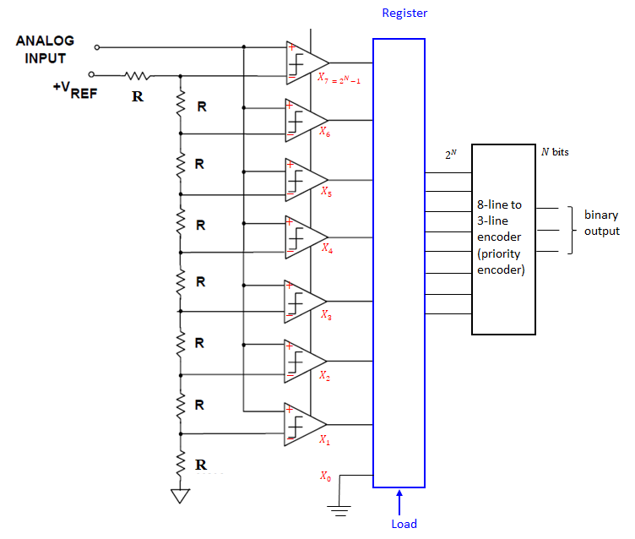

Sweep/Ramp Generator:

The ramp generator was another all around good method. While it provides a lower speed, a ramp generator has the possibility of a very good resolution and only a medium cost. The circuit may require calibration and should be easy enough to build. A single power rail should work for this method as well instead of requiring positive and negative power rails.

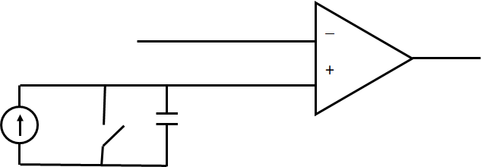

Successive/Serial Approximation:

This ADC proved to be the most well-rounded method in our research. It has a medium speed, medium precision, and a medium cost to it. In this project we will need to use one with a 6-bit resolution and this ADC requires the use of a positive and negative power supply. 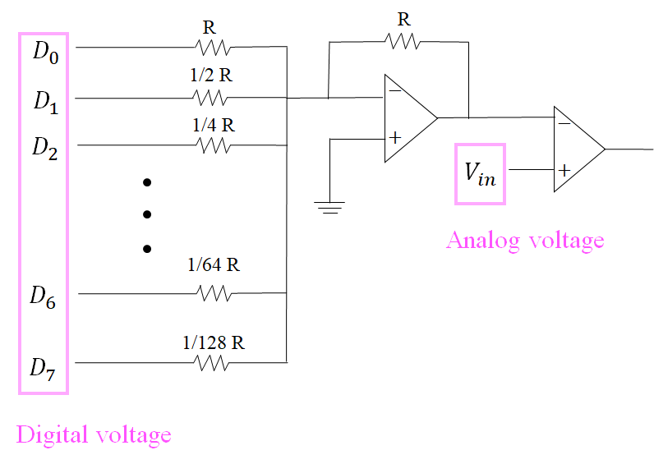

\

**Decision Matrix Parameters:**

For our decision matrix parameters, our group wanted to have parameters relevant to the project and circuit design. We used the current project requirements to get a basis of what the circuit would need to do and the we also compared and contrasted the ADC circuits to get an idea of which would be best.

Our current project 2 requirements are:

1. The input analog voltage will range will be 0-10Vdc (test voltage)

2. The measured voltage will be displayed on a computer monitor with two decimal points

3. The Arduino Uno will measure the input analog voltage (test voltage).

4. The test voltage measured by the Arduino will be displayed on a computer monitor.

5. The measured voltage derived from A/D circuit will be displayed by the Arduino.

6. The difference between the voltage measured by the Arduino (test voltage) and the team’s circuit should average less than 2% over the entire voltage input range.

7. The percent difference between the voltage measured by the Arduino and the team’s circuit will be displayed on a computer screen.

The parameters we came up with are:

* Precision
* Speed
* Complexity
* Cost
* Accuracy

**Out of Class Meeting:**

Our out of class meeting took place in the engineering building when we were all free at the same time. Each group member was present for the meeting. The meeting mainly consisted of us clearing up what the project was asking for and researching solutions to the project. We all found various videos and websites that can help us in deciding which method will be the best for us to use. Each team member did an equal amount of participation during this meeting and we actually got a large amount of research done. This meeting definitely helped us get a foot in the door on this project.

**Conclusion:**

With all this data in mind we are now ready to create a decision matrix in order to find which method will solve our problem. Currently all methods look plausible but our group is starting to form opinions towards some over others.With a decision matrix, our group will be able to see which one will be the best and solve all of the project requirements. Right now we are in between the sweep generator and serial approximation, but this could easily change with more research.

**Attachments:**

Images of a ramp generator, serial approximation, and flash converter ADC provided during in-class lecture.